- NETWORK THREATS AND PHYSICAL SECURITY ASSIGNMENT
Q1. Five Common Network Threats
Threat | Meaning | Real-World Example | Protection
Phishing | Fake messages/pages steal login details. | A fake Instagram login link asks for a username and password. | Check links and use MFA.
DDoS | Huge traffic makes a service unavailable. | Attack traffic overloads a food-delivery service so users cannot place orders. | Use DDoS protection and rate limiting.
Man-in-the-Middle | An attacker intercepts communication. | A user on an unsafe network is targeted while accessing a payment service. | Use HTTPS/TLS and trusted networks.
Malware | Malicious software steals or damages data. | A fake app or attachment installs malware and steals account information. | Use updates and endpoint protection.
Password Attack | Attackers guess or reuse stolen passwords. | An attacker tries reused passwords against an Instagram account. | Use unique passwords, MFA and login rate limits.

Q2. Brute-Force PIN Simulation in Python
This safe local demonstration checks a preset 4-digit PIN from 0000 to 9999 and counts the attempts. It does not connect to any real account or service.
preset_pin = "2468"
attempts = 0
for number in range(10000):
guess = f"{number:04d}"
attempts += 1
if guess == preset_pin:
print("Correct PIN:", guess)
print("Number of attempts:", attempts)
break
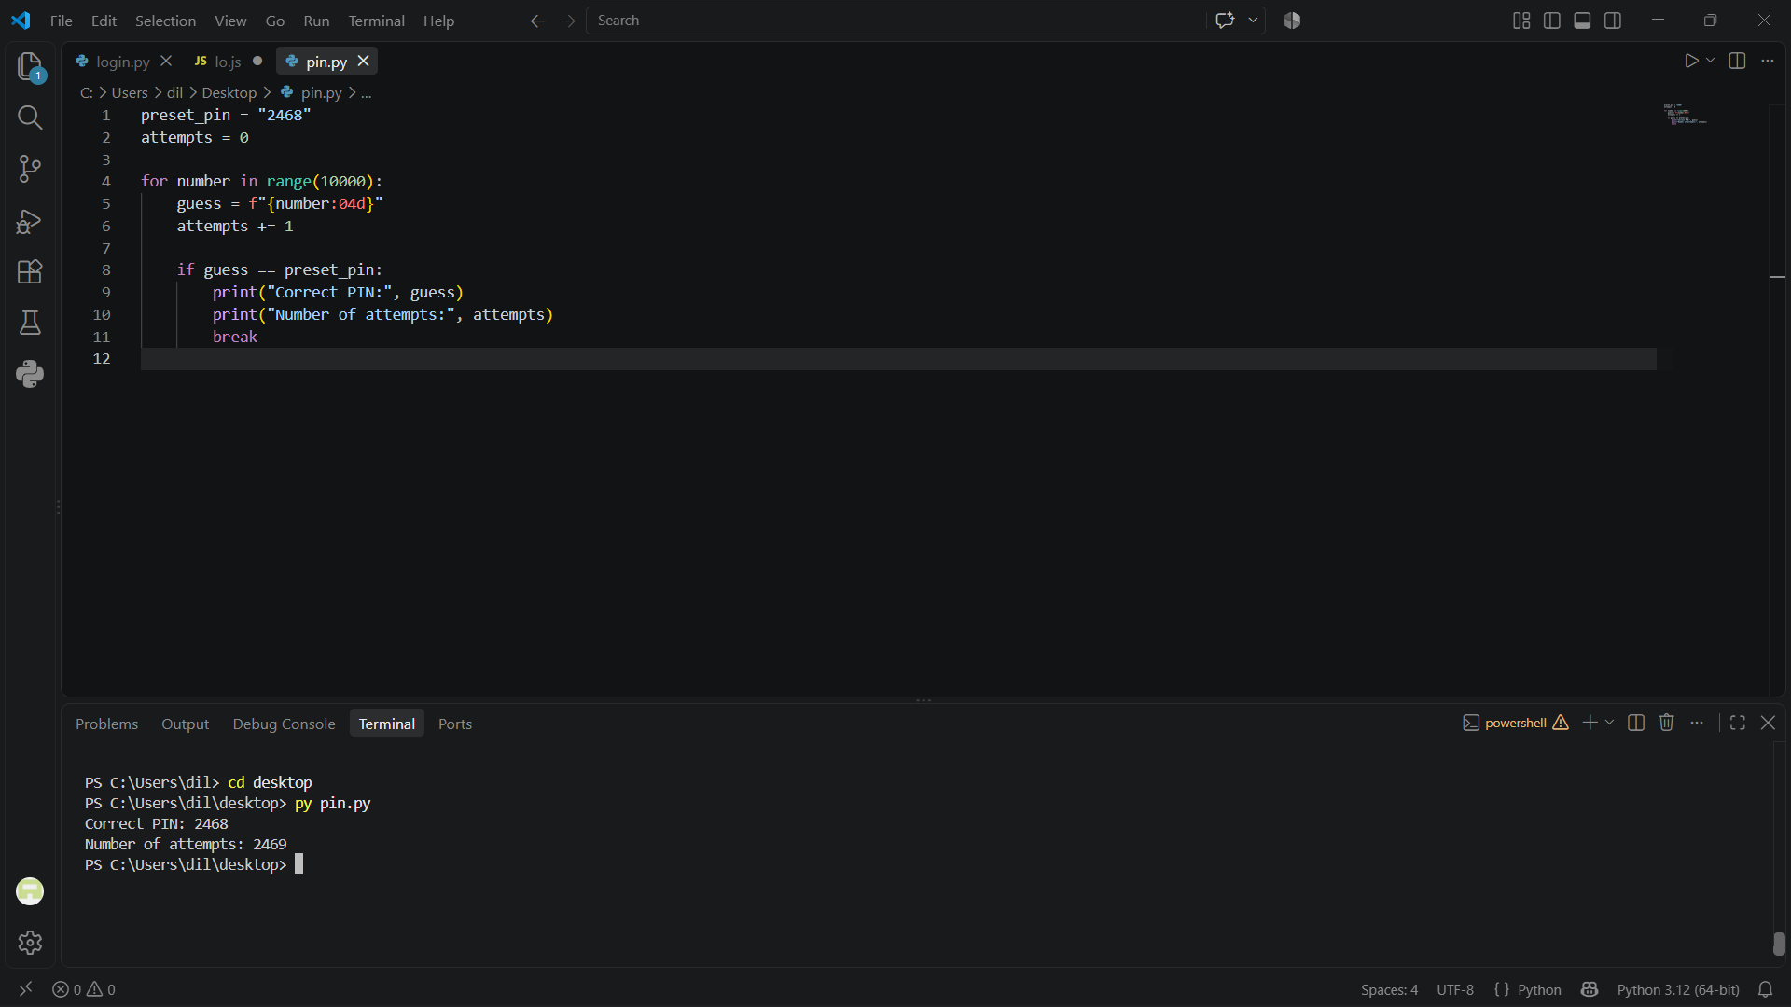
Q3. Four Physical Security Risks and Mitigation
Risk | Possible Effect | Mitigation
Unauthorized Entry / Theft | Servers or network devices may be stolen or tampered with. | Use locked doors, controlled access and CCTV.
Fire | Fire can destroy servers, cables and data. | Use smoke detection and suitable fire suppression.
Power Failure / Surge | Sudden shutdown or hardware damage may occur. | Use UPS, surge protection and backup power.
Water Leak / Flooding | Water can damage electrical/network equipment. | Raise equipment from the floor and use leak detection.

Q4. Small Office / College Lab Floor Plan
The following digital floor plan marks physical security measures used to protect network equipment.
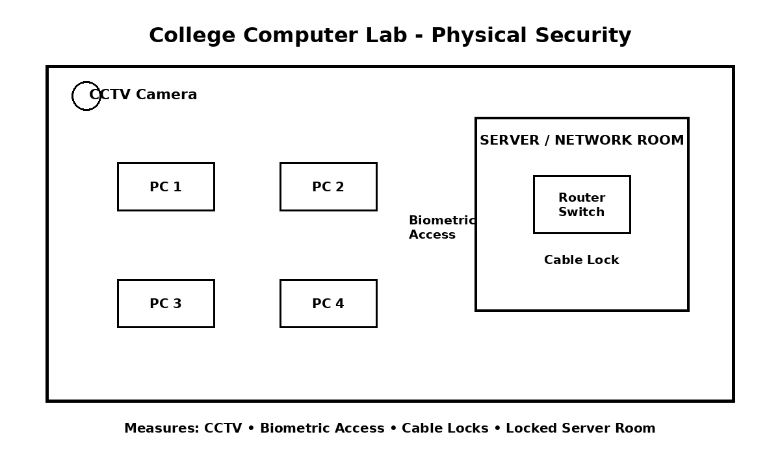
The three main measures are CCTV monitoring, biometric access to the server/network room, and cable locks. A locked server room provides additional protection.
Q5. Seven-Action Security Checklist for a College Computer Lab
- ☐ Keep Windows, browsers, antivirus/endpoint protection and lab software updated on every PC.
- ☐ Use firewalls on lab PCs and the network gateway; allow only services and ports required for classes.
- ☐ Give students standard user accounts instead of administrator accounts and protect staff/admin accounts with strong passwords.
- ☐ Use secure Wi-Fi and separate student access from staff/network-management access where possible.
- ☐ Back up important lab data and network configurations regularly and test that important backups can be restored.
- ☐ Keep routers, switches and servers in a locked rack or room; use CCTV, controlled staff access and cable locks where appropriate.
- ☐ Teach students and staff to recognize phishing, suspicious downloads and unknown USB devices, and report security incidents quickly.
Review:
This edited checklist is specific to a college computer lab because it focuses on shared student PCs, limited user privileges, lab software updates, secure network equipment, backups and student security awareness.
Conclusion
A secure college computer lab needs both network security and physical security. Firewalls, updates, strong access control and user awareness reduce network threats, while CCTV, controlled entry, power protection and locked equipment reduce physical risks.

